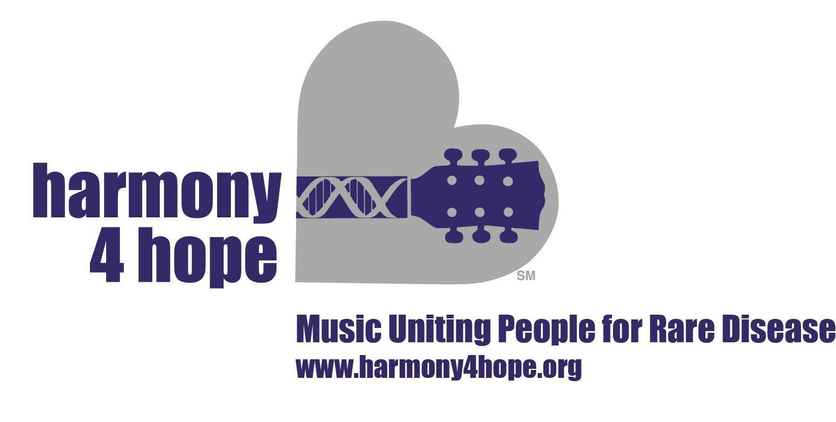

Harmony 4 Hope (H4H) is an Illinois not for profit corporation established in 2014 for the purpose of serving the 350,000,000 people worldwide collectively impacted by 7,000 distinct rare diseases. As set forth in its government documents, (H4H) is organized and operated exclusively for charitable purposes in accordance with section 501(c)(3) of the Internal Revenue Code of 1986.

The mission of H4H is to fuel scientific discovery in Rare Disease, educate future physicians and researchers and uplift patients and families with gifts of music and music therapy. Merging music and storytelling, we deliver this mission nationally. For several years, H4H has championed the cause of rare disease patients and has widely communicated the need for increased attention and funding to address these serious illnesses.

In addition to the organization’s established educational activities, and in furtherance of its charitable purposes, H4H will fund a research project that benefits pediatric patients facing difficult diagnoses, specifically those affected by rare diseases.

The budget for this grant is $20,000 USD (“Funds”). The Funds will be dispensed in two $10,000 installments in March and September 2024

H4H will distribute the Funds on the basis of objective non-discriminatory criteria. Specifically, H4H will not discriminate against potential recipients on the basis of any protected class. In addition to this general selection principle, H4H will show preference to research programs with the following characteristics:

- The research must address one or more rare diseases, that is, conditions affecting fewer than 200,000 people.

- Research addressing any rare disease will be considered; H4H will not be partial to any specific rare disease state.

- Preference will be given to applicants who are qualified investigators for preclinical, clinical research or clinical practice.

- Research projects that have as their goal the pursuit of pharmaceutical or other commercially supported continuing grants are permitted provided that all Funds as granted to the research program are used exclusively in furtherance of the projects’ research and scientific objectives.

- Qualified studies should be supportive of new diagnostics and/or therapeutics for rare diseases.

- Preference will be shown for projects to be conducted at major research and medical educational institutions.

The application window is from January 6 to February 6, 2024. Grant Fund recipients will be notified no later than March 1, 2024

All applicants must submit a brief abstract of their proposed research together with a completed application for the research project. The grant funding application is attached hereto as an exhibit below.

